The number of edges(roads) is constanted as 6, which is the number of vertexes - 1. I used Kruskal’s algorithm to solve this question.

|  |  |
| --- | --- |
| road | cost |
| A-B | 1 |
| A-C | 2 |
| E-F | 3 |
| F-G | 3 |
| D-G | 3 |
| B-F | 5 |
| B-C | 6 |
| B-E  D-F  C-D  C-F  A-G | 7  7  8  9  11 |

Firstly, sort the roads by their cost from small to large:

Then, if the two vertexes aren’t connected to be a circle, then put the roads back from small to large:

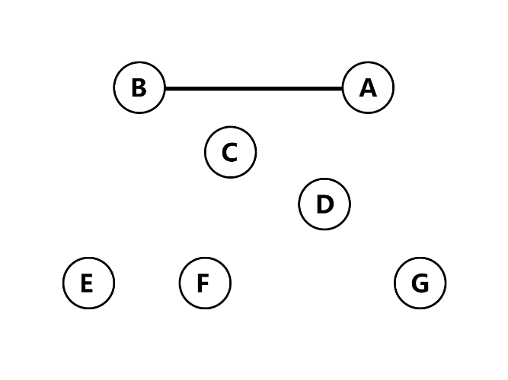

As A and B are not connected to be a circle, Connect A and B.

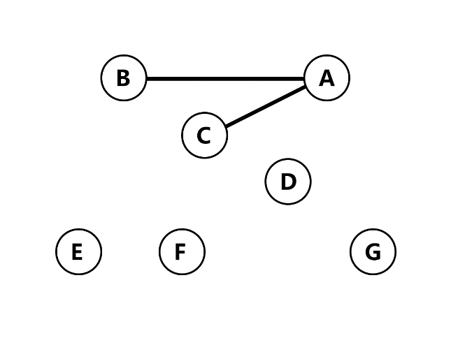Then connect A and C.

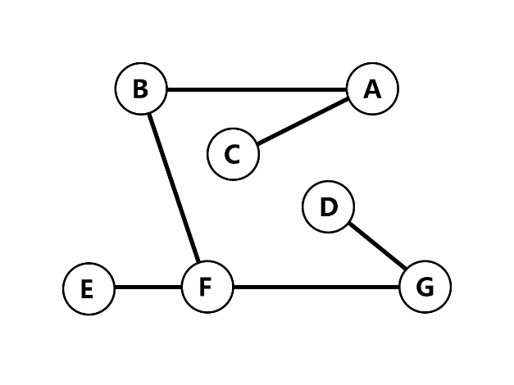

Do the same thing to E-F, F-G, D-G,B-F.

When the number of roads reaches 6, stop connecting and add the costs together: 1 + 2 + 3 + 3 + 3 + 5 + 6 = 23(million pounds).